European Policy Dialogue Forum
Follow-up Initiatives

Rationale

Recognising the wealth of connections, innovative ideas and policy insights coming out at each edition of the European Policy Dialogue Forum (EPDF), the Europe Region Programme of the International Dialogue Centre (KAICIID) provides opportunities for follow-up initiatives, pooling the transformative power of dialogue - interreligious, intercultural and intergenerational - towards building mutual trust and a conducive environment for social cohesion and climate justice.

EPDF Follow-up Initiatives
Micro-grants opportunities
After each EPDF, the Europe Region Programme will launch a call for proposals aimed at mobilising key actors, to translate the insights of the EPDF into actions at the local level. The intention is to engage especially those who may not have extensive prior project experience, but who are motivated to gain hands-on practice, test innovative approaches, and strengthen their capacity to mobilise communities.
Interreligious dialogue will serve as the key method, fostering understanding and collaboration across diverse faith and belief communities, and ensuring that locally driven initiatives contribute to more inclusive, cohesive and sustainable societies.
Successful applicants will have access to capacity-development on interreligious and intercultural dialogue together with technical and financial support to put their ideas in motion.

Cities for Inclusion Workshops - C4I
  - WHY: to generate action-oriented cooperation at local level, and promote values-based, inter-faith experiences.
  - WHO: local actors, including city authorities, youth groups, universities and the private sector, religious leaders and actors, civil society and faith-based organizations.

Focal Point: Ms. Jana Jakob, KAICIID Europe Region Programme Officer – Jana.Jakob@kaiciid.org

Catalysts for Cohesion - C4Ɔ
  - WHY: to leverage youth changemaking potential towards cohesive and sustainable communities.
  - WHO: young people aged 18-30, including young migrants and refugees, youth-led groups, movements and associations located in the 46 countries of the Council of Europe.

Focal Point: Mr. Tim Mortimer, KAICIID Europe Region Programme Officer - Tim.Mortimer@kaiciid.org

Network for Dialogue (N4D) migrant and refugee inclusion grassroot initiatives

- WHY: to harness interreligious and intercultural dialogue to foster refugee and migrant inclusion in host communities, making the two-way integration process an asset for social cohesion, peaceful coexistence and local prosperity.
  - WHO: members of the Network for Dialogue (N4D) active in the 46 countries of the Council of Europe.
Focal Point: Dr. Aleksandra Djuric Milovanovic, KAICIID Network for Dialogue Coordinator - Aleksandra.Djuric@kaiciid.org

KAICIID-led events
KAICIID-led events bring together diverse stakeholders - from grassroots actors to policymakers and faith leaders - through multiple tailored formats. At the heart of every event is interreligious and intercultural dialogue (IRD/ICD), explored not just as a concept but as a practical tool to drive transformative change. By demonstrating how IRD/ICD can inform inclusive policies and foster equitable practices, these events spark new ideas, guide programmatic innovation, and mobilize communities toward cohesive, resilient, and sustainable societies across Europe
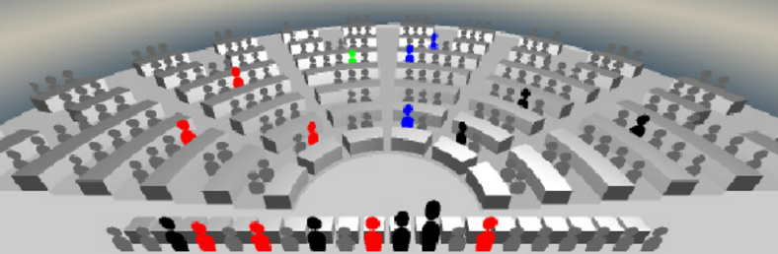
KAICIID European Parliamentary Talks
  - WHY: to mobilise parliamentary assemblies about interreligious and intercultural dialogue as essential methods to build cohesive and sustainable communities in Europe
  - WHO: regional and national parliamentary assemblies.
Focal Point: Ms. Teresa Albano, Senior Programme Manager, Europe Region Programme – Teresa.Albano@kaiciid.org

University Talks with KAICIID

  - WHY: to bridge the gap between academic research and policymaking and implementation offering an interreligious and intercultural approach with the intention to discuss the untapped potential for inter-faith cooperation around the priorities of the EPDF Call to Action.
  - WHO: university students aged 18-30 and professors, including young migrant and refugee students.

Focal Point: Dr. Aleksandra Djuric Milovanovic, KAICIID Network for Dialogue Coordinator - Aleksandra.Djuric@kaiciid.org

KAICIID Reflective Roundtables

- WHY: to collect inspirational insights from selected influential secular and religious leaders some of the major challenges we face today, promote inclusive partnerships and call for the ethical urgency to act together to foster global solidarity and promote human dignity.
  - WHO: up to 35 selected influential secular and religious leaders and institutions.

Focal Point: Ms. Jana Jakob, KAICIID Europe Region Programme Officer – Jana.Jakob@kaiciid.org

KAICIID side events

  - WHY: Specially curated sessions held alongside major international conferences, designed to bring focused attention to pressing issues in interreligious and intercultural dialogue. These events provide a platform for high-level exchange among policymakers, faith leaders, and civil society actors, combining the agility of a side event with the depth and strategic relevance of the discussion, showcasing innovative practices, and generating actionable insights that inform policy and programmatic decisions

  - WHO: in cooperation with international organisations and other key stakeholders.

Focal Point: Ms. Teresa Albano, Senior Programme Manager, Europe Region Programme – Teresa.Albano@kaiciid.org

For general questions, get in touch with us at europe@kaiciid.org

